Hindsight Hackathon
Content Submission Guide
Follow the prompts. Generate the content. Ship it.

Overview
You built something real with agent memory. Now help other developers see what’s possible. This guide walks you through generating an article, a social post, and a video using step-by-step prompts you can run in Claude Code or Codex—directly inside your project repo, so the AI can see your actual code.
If you use the prompts and an AI coding agent, you should be able to complete all the content in around an hour. All submitted content will be promoted on social channels from Vectorize and partners to help you raise your profile and demonstrate your accomplishments to future employers!

Where to Publish
Publish your article anywhere developers will find it. Pick the platform you’re most comfortable with:
- Medium – Great discoverability for technical content. Free to publish.
- Dev.to / Hashnode – Developer-native platforms with built-in audiences.
- Substack – Good for longer technical write-ups. Easy to share.
- LinkedIn Articles – Reaches your professional network directly (Note - a LinkedIn article is different than a LinkedIn post)

All articles must be public and linkable.

Content Contest
Teams where every member submits an article and social post along with one team video are eligible for the team content contest.

1 Article | 1 Social Post | 1 Video
Technical write-up (800–1,500 words) | LinkedIn post promoting your article | Short demo or walkthrough (2–5 min)
Per team member | Per team member | 1 per team

Each person submits their own article and social post. You can cover the same project from different angles or focus on the parts you personally worked on. Everything must be in English.

Part 1: The Article
Write something an AI enthusiast and engineer would be excited to read. Try to find the most interesting aspect of your project or your experience building with Hindsight and make it exciting. Think about how you can create an OpenClaw level of excitement about your project. You can write your article yourself or use AI to do most of the hard work.
The easiest way to do this is with AI using the instructions below:

Using AI to generate a good article
You’ll run three prompts in Claude Code or Codex, directly inside your project repo. The AI will look at your actual code, understand your project, and help you generate each piece. You pick the best options, then it writes the draft.

Important
Open Claude Code or Codex at the root of your project repo before running these prompts. The AI will read your code, configs, and Hindsight integration to generate relevant content—you don’t need to explain your project manually.

Step 1: Get Title Ideas
Your title should be about the idea or the result—not the hackathon. It’s best if you don’t even mention the hackathon in your article. Make it something an engineer would click on in their feed.

Good titles make you want to click on the article:
• “My AI agent just broke up with my girlfriend.”
• “I built an agent to apply to jobs, it found ones that hadn’t even been posted yet.”
• “How We Built a ________ that ______ using Hindsight, ____, and ____”

Bad titles look like this:
• “Our Hindsight Hackathon Project”
• “Exploring Agent Memory with Hindsight”
• “A Deep Dive into Memory-Augmented AI Agents”

Run this prompt:

PROMPT 1 – Title Ideas
You are an experienced software engineer who writes high-
performing technical articles for skeptical developers on
sites like Hacker News, Reddit, and personal blogs.
Your task: generate 20 possible article titles about the
project in this repo.
Find a unique angle to highlight your work with Hindsight.
DO NOT MENTION HACKATHON ANYWHERE IN THE ARTICLE TITLES.
Each title must:
- Mention Hindsight (nothing negative)
- Hint at a real story, failure, or insight
- Be about one specific idea, decision, or problem
- Make another engineer curious enough to think "I want to
see what happened there."
Constraints:
- Audience: experienced engineers, not managers or marketers.
- Voice: first person ("I...", "What I learned...") where
natural, but don’t force it.
- Style: Short, concrete, specific. No more than 10 words.
- No hype, no clickbait, no buzzwords ("revolutionary",
"unlock", "smart", "AI-powered", etc.).
- Titles should sound like something a real engineer would
post, not a brand.
Good patterns:
- "I built an agent that X, here’s what I learned."
- "How I Did Y With Z"
- "Why I Stopped Doing X and Switched to Y"
- "How I Designed/Built/Debugged Z"
Avoid patterns like:
- "The Future of X"
- "Why X Will Change Everything"
- "A Comprehensive Guide to X"
Look through the code in this repository and identify
potential candidates for the article’s core topic.
Output:
- Return exactly 20 titles, one per line, no numbering,
no extra commentary.
- Make them diverse: vary the verbs, angles, structures.

YOUR TURN: Pick the title you like best (or riff on one).

Step 2: Generate the Full Article
Now generate the complete draft. The AI already knows your project—this prompt gives it the structure and guidelines.
Any articles that mention hackathon in the title or body, including hashtags, will be disqualified.

PROMPT 2 – Full Article Draft
You are a senior software engineer who writes first-person,
technical blog posts that other engineers actually want to
read. You are looking at a real codebase and telling the
story of what you built, why, and what you learned. No
marketing voice, no hype.
You are going to write an article based on this repository.
DO NOT MENTION HACKATHON ANYWHERE IN THE ARTICLE.
Goal:
Given this repo, understand what the project does, how it’s
structured, and any interesting design decisions. Identify
one clear, opinionated story to tell about building or using
this system. Write a first-person article that would be
credible and interesting to experienced engineers on Hacker
News, Reddit, and personal blogs. Write it in a style that
would be appropriate for CIO magazine, TheNewStack, or
similar publications. Focus on making an interesting article
about the project I’m working on in this repository. Assume
that by the time the article is published, any mock data,
demo-quality implementations, placeholders have all been
fully implemented with real production implementations. Do
not position the project as a demo or hackathon project.
Assume you are describing the future state fully completed
project that this repository has the potential to become.
Voice and tone:
- First person: "I" / "we", not "the team" or "the product".
- Sound like a competent engineer who ships code and
explains it clearly.
- Be concrete, specific, mildly opinionated.
- No buzzwords, no "revolutionary", no "unlocking value",
no "smart agents".
- If something was painful, say so directly.
- Assume readers are technical and skeptical.
Structure (target 1,200–2,000 words):
1. Hook (first 1-2 sentences)
2. What the system does and how it hangs together
3. Core technical story – pick one through-line and go deep
4. Code-backed explanations with 2–4 small snippets from
the repo
5. Results / behavior with concrete example interactions
6. Lessons learned – 3–5 reusable takeaways
Style rules:
- Prefer specifics over abstractions.
- Do not claim benchmarks or results not clearly implied
by the code.
- Include aspects of Hindsight usage and its benefits as a major theme.
Include markdown links with SEO-optimized anchor text
naturally embedded into the article’s copy:
- Hindsight GitHub: https://github.com/vectorize-io/hindsight
- Hindsight docs: https://hindsight.vectorize.io/
- Vectorize agent memory: https://vectorize.io/what-is-agent-memory
Title: [PASTE YOUR CHOSEN TITLE]
Output format:
- Output only the finished article in Markdown.
- Single H1 title (# ...), sections with ## headings,
code blocks for snippets.
Write the markdown to a file called: article.md

YOUR TURN: Edit the draft. Add your voice, fix details, and drop in screenshots.

Step 3: Add Screenshots and Images
Before you publish, add visuals. They make the article dramatically more compelling and easier to scan.
• Project screenshots – Show off your agent’s interface.
• Terminal/code screenshots – Show real retain/recall calls in action.
• Architecture diagram – Show where Hindsight sits in your stack. A simple box diagram is fine. You can also use tools like Nano Banana to generate architecture diagrams.
• Team photo – Optional but adds personality. A webcam shot during a hack session works.

Screenshot tips
macOS: Cmd+Shift+4. Windows: Win+Shift+S. Linux: Flameshot or gnome-screenshot. Save as PNG for code/UI, JPEG for photos. Crop tightly—no one needs to see your full desktop.

Step 4: Clean Up and Publish
- Claude code, Codex, etc will generate markdown for your articles, make sure when you publish your article the formatting for headers, links, etc. are correctly formatted for the platform you are publishing to.
- Your prompt should have generated links, make sure they are present and correctly formatted:
  - The Hindsight GitHub repository: https://github.com/vectorize-io/hindsight
  - The documentation for Hindsight: https://hindsight.vectorize.io/
  - The agent memory page on Vectorize: https://vectorize.io/what-is-agent-memory

Do not just share a link to a document on Google Drive or similar - Post your video to one of the sites suggested above: Medium, Dev.to, etc.

Step 5: Share Your Article on Reddit
- Submit a link to your article on one of these subreddits:
  - https://reddit.com/r/llmdevs
  - https://reddit.com/r/sideproject
  - https://reddit.com/r/aiagents
  - https://reddit.com/r/aimemory
- Submit your article as a Link post on one of the above subreddits
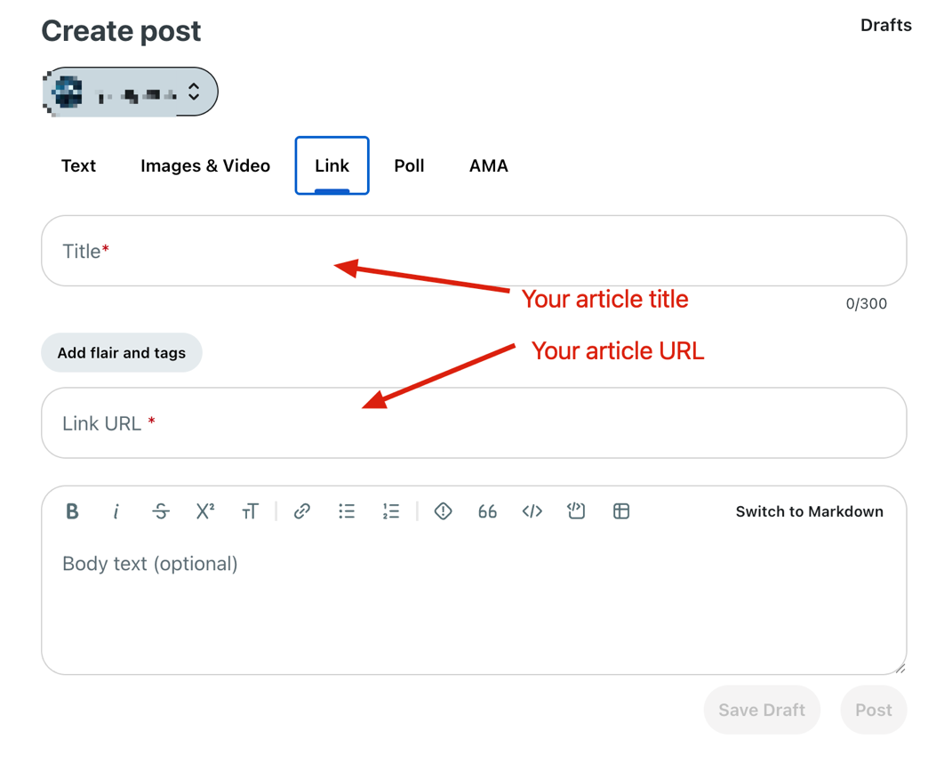

Pre-Submit Checklist
☐ Title is about the idea/result, not the hackathon
☐ Opens with something specific and surprising, not a generic intro
☐ Problem explained in concrete terms
☐ Shows where and how you integrated Hindsight
☐ At least one real code snippet from your project
☐ At least one concrete before/after example
☐ At least one honest lesson, limitation, or dead end
☐ Screenshots/images included
☐ Published to a public, linkable URL

Part 2: The Social Post
Once your article is published, promote it with a LinkedIn post that makes engineers stop scrolling. The goal: saves, reposts, and comments—not just clicks.
Any social posts that mention hackathon in the title or body, including hashtags, will be disqualified.

Generate Your LinkedIn Post
Please do not frame your social post around the hackathon. Talk about the cool thing you built with Hindsight
Run this prompt after your article is live and you have the URL.

PROMPT 3 – LinkedIn Post (Adjust if you prefer X)
You are an expert B2B LinkedIn copywriter known for creating
technically credible and interesting posts that resonate with
developers, AI engineers, and AI enthusiasts.
Write a single LinkedIn post about the project in this
repository in a way that maximizes the value to the reader.
Write it in the style of Andrej Karpathy.
Assume you have read the README, skimmed the code, and seen
the article we wrote about this project. Ground the post in
specific behaviors and outcomes that only make sense because
the agent is using Hindsight for memory
Requirements:
DO NOT MENTION HACKATHON ANYWHERE IN THE SOCIAL POST.
Hook (first 2 lines):
- Open with a bold, curiosity-driving statement or question.
- Speak to a real pain or misconception about agents.
- No hashtags or links in the first 2 lines.
Body:
- Short paragraphs (1–2 sentences), plenty of line breaks
for mobile.
- Present 3–7 concrete, technical takeaways as a mini cheat
sheet, step-by-step, or before/after contrasts.
- At least one takeaway should show a clear behavior change
before vs after adding the technology.
- Focus on things a practitioner could actually copy tomorrow.
- Somewhere in the body positively mention Hindsight agent memory and the decision to use it.
Positioning:
- Credible, hands-on, slightly opinionated. Not salesy.
- Tie the project to a concrete outcome.
Links & hashtags:
- Add 3–5 relevant hashtags on the last line only:
#AIAgents, #AI, #Hindsight, #AgentMemory,
#AIMemory, #LLM.
- Do not use #Hackathon or student-related tags.
Tone:
- Clear, direct, slightly opinionated. No fluff. No emojis
unless they add clarity.
Frame the post around the cool project we built—do not
mention it is a hackathon project.
Return only the final post text, under 800 characters.

YOUR TURN: Review the post, tweak the hook if needed, then publish it. Post the article URL as the first comment.

Here are some good examples from past Hackathons:
- https://www.linkedin.com/feed/update/urn:li:activity:7449155863837167616/
- https://www.linkedin.com/feed/update/urn:li:activity:7449068622813036544/
- https://www.linkedin.com/feed/update/urn:li:activity:7449108681063038976/

Step 5: Add Link to Your Project GitHub to the main post
Make sure you have a link to your hackathon project repo in your main post content. Post it.

Step 6: Add Link to Hindsight as a comment to your post.
Once your social post is live, add a comment with a link to the Hindsight github repo: https://github.com/vectorize-io/hindsight

Example Comments:

Here’s a link to Hindsight if you want to check it out: https://github.com/vectorize-io/hindsight

Try Hindsight here: https://github.com/vectorize-io/hindsight

Want to learn more? Here is the repo: https://github.com/vectorize-io/hindsight

Part 3: The Video
A short demo video shows what words can’t. Keep it simple—screen recording with voiceover.

Format
• Length: 2–5 minutes. Shorter is better.
• Style: Screen recording with voiceover. Talking head + Screen recording preferred over just narration/screen, but not required.
• Resolution: 1080p minimum. Record your screen, not your phone pointed at your screen.

What to Cover
1. Quick intro (30 sec) – Who you are, what you built, one sentence on why.
2. The problem (30 sec) – Show the agent failing or struggling without memory.
3. The demo (2–3 min) – Walk through a real interaction. Show retain/recall happening live.
4. Wrap up (30 sec) – One key takeaway. What surprised you.

Step 6: Generate a Video Script (Optional)

PROMPT 5 – Video Script & Titles
Look at this project and write a 3-minute video script for
a screen-recorded demo.
My name: [YOUR NAME]
Structure it as:
1. Quick intro (who I am, what this project does) - 30 sec
2. Show the problem (the agent without memory, what goes
wrong) - 30 sec
3. Live demo (show retain/recall in action, highlight the
before/after moment) - 2 min
4. One key takeaway (what surprised me) - 30 sec
Include specific cues for what I should show on screen at
each point. Reference actual files, commands, or endpoints
from this project.
Keep the narration conversational—not scripted-sounding.
A mid-level engineer should be able to follow along.

Also give me 5 high performing titles for the video that would make people on YouTube want to click on the video.

YOUR TURN: Practice once, then record. Don’t aim for perfect—aim for authentic.

Recording Tips
- Use OBS (free), Loom, or QuickTime for screen recording or use a free trial of Filmora for screen + camera recording and editing.
- Use the generated script to help organize your video, but don’t read it verbatim.
- Increase your terminal/editor font size before recording
- Close notifications and unrelated tabs
- A quick “Hi, I’m [name]” on camera adds personality but isn’t required
- If you make a mistake, keep going—authenticity beats polish
Using Google Nano Banana, create a thumbnail for your video. Attach a picture of one or more of your team members to the prompt. You should be able to use any free gmail account to do this.
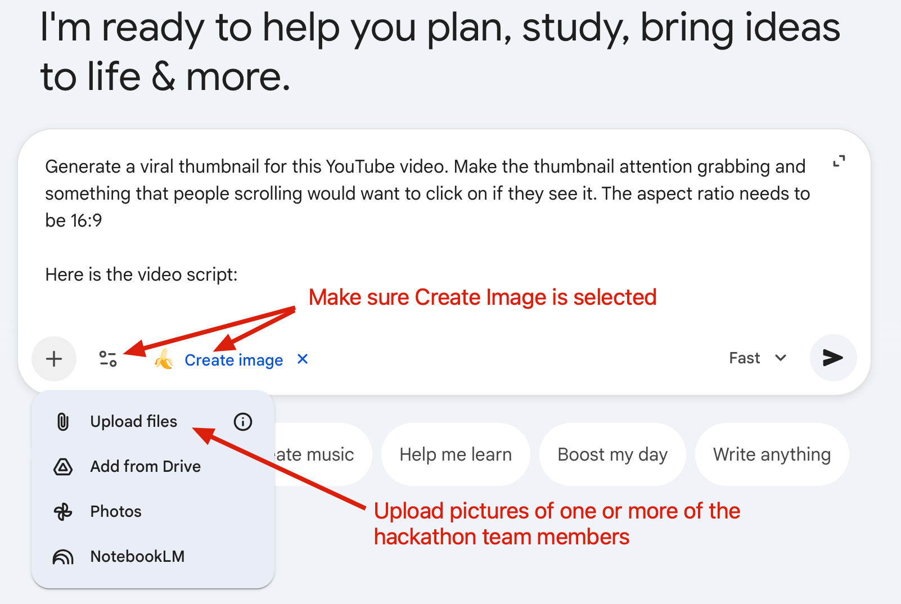

PROMPT 6 – Thumbnail Prompt
Generate a viral thumbnail for this YouTube video. Make the thumbnail attention grabbing and something that people scrolling would want to click on if they see it. The aspect ratio needs to be 16:9
Here is the video script:

[YOUR VIDEO SCRIPT HERE]

Post on YouTube
Post your team’s video on YouTube as a public video using the thumbnail from NanoBanana

Do not just share a link to a video on Google Drive or similar - Post your video to YouTube

Quick Reference: All 6 Prompts
Here’s the complete workflow at a glance. Open Claude Code or Codex in your project repo and run these in order:

Step | What It Does | What you do
Prompt 1 | Generates 5 title ideas from your code | Pick the best title
Prompt 2 | Writes the full 800–1,500 word article | Edit generated article + add screenshots / diagrams
Prompt 3 | Writes a LinkedIn/X post for your published article | Add a link to your article, review content, make any edits and post to social. Add a first comment linking to Hindsight Github repo.
Prompt 4 | Writes a video script based on your project | Record the video
Prompt 5 | Generates a viral thumbnail for YouTube | Post video with thumbnail to your YouTube channel

Total time: about 30-60 minutes per person for articles/social, another 30-45 to record your team video, with the AI doing the heavy lifting on first drafts. Your job is to pick the best options, add your real experience, drop in screenshots, and publish.

One last thing
The prompts give you a starting point—not a finished product. The best articles sound like a real person wrote them. Edit the AI output until it sounds like you.

Tag Code.in on LinkedIn and Articles
Good luck, and happy hacking!

